How to Access Your School Email Account

- Accessing school email

From https://polkschoolsfl.com/ go to “Classlink for Students.”
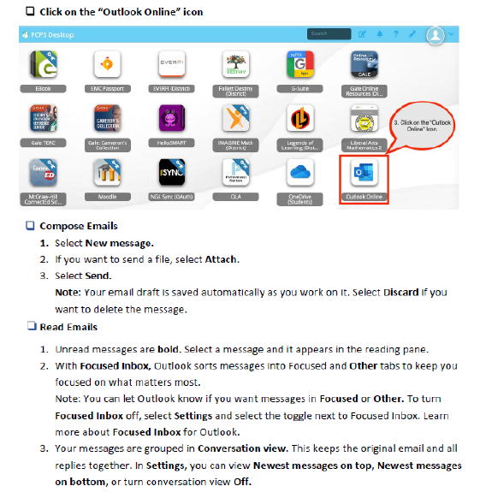
- Accessing Mrs. McKinney’s Website

My website address is: https://5thmckinney.weebly.com/

